**project plan 2**

Visionary Minds

|  |
| --- |
| Team |
| Abirami Mohanasundaram |
| Mounika Boju |
| Parth Babubhai Kalathiya |
| Rechael Vincent Lopes |

**Declaration Statement**



We, Abirami Mohanasundaram, Mounika Boju, Parth Babubhai Kalathiya, and Rechael Vincent Lopes affirm that the attached work is entirely our own, except where the words or ideas of other writers are specifically acknowledged in accordance with accepted APA citation conventions. This project is specifically made for our client BTC Enterprises. We acknowledge that we have revised, edited, and proofread this paper, and we certify that we are the author of this paper. Any assistance we received in its preparation is fully and properly acknowledged and disclosed. We have also cited any sources from which we used data, ideas, theories, or words, whether quoted directly or paraphrased. We further acknowledge that this paper has been prepared by ourselves specifically for this project.

Our team has spent approximately 10 hours on this assignment.

Signatures

Mounika Boju

Abirami Mohanasundaram



Rechael Vincent Lopes

Parth Babubhai Kalathiya

**Abstract**

This Abstract provides the overall workbehind the second phase of our project plan, which focuses on creating a strategic framework for the IT department using wireframes and connecting to prototypes. The main goal of this section is to develop comprehensive strategies in the IT department to increase the effectiveness and efficiency of the department by interacting with multiple web pages. Our project team performs a detailed analysis of organizational goals, resource allocation, and workflow optimization to design solutions tailored to the department's specific needs. By implementing these strategies, management can expect to improve processes, streamline workflows, and increase productivity.

Abstract word count: 100

Table of Contents

Team Contributions 6

References 7

Academic Appendix 8

Wireframes 11

Prototypes 25

Peer Review (Given) 29

Peer Review (Received) 31

Client Review 33

Gantt Chart Tasks 35

Table of Figures

Figure 1: Home page IT department 14

Figure 2: Onboarding page IT department 15

Figure 3: Manual and User Guide page 16

Figure 4: IT request track form 17

Figure 5: Incident Management Tracking page 18

Figure 6: Hardware support 19

Figure 7: Knowledge Base 20

Figure 8: Reach out to us 21

Figure 9: Internal project updates 22

Figure 10: workshop update page 23

Figure 11: Backup and Recovery page 24

Figure 12: Prototype for the entire website 26

Figure 13: Prototype linking for all pages using the Homepage 27

Figure 14: Prototype linking of all pages 28

Figure 15: Gantt Chart Tasks 35

# Team Contributions

|  |  |
| --- | --- |
| Members | Tasks |
| Mounika Boju | Document Creation  Document completion (Includes entire doc) |
| Abhirami Mohanasundaram | Wireframe creation  Prototype Linking to wireframes  Gantt chart |
| Parth | PowerPoint presentation |
| Rechael Lopes | Wireframe creation |
| All Team members | Discussion- scrum meeting, review |

# References

*Wireframes -* <https://www.figma.com/resource-library/what-is-wireframing/>

Academic Appendix

|  |  |
| --- | --- |
| Acronym | Abbreviation |
| M365 | Microsoft 365 |
| AD | Azure Active Directory |
| IAM | Identity and Access Management |
| VPN | Virtual Private Network |
| WBS | Work Breakdown Structure |
| UAT | User Acceptance Testing |
| IT | Information Technology |
| PM | Project Manager |
| BA | Business Analyst |
| TL | Technical Lead |
| SA | System Architect |
| IT | Information Technology |
| HR | Human Resources |
| QA | Quality Assurance |
| M365 | Microsoft 365 |
| DBA | Database Administrator |
| AWS | Amazon Web Services |
| AD | Active Directory |
| LDAP | Lightweight Directory Access Protocol |
| RBAC | Role-Based Access Control |
| UAT | User Acceptance Testing |
| LMS | Learning Management System |
| SQL | Structured Query Language |
| DB | Database |

Project Name: BTC Enterprises

The Project aims to better utilize the M365 Platform to majorly tackle 3 issues the client faces.

1. Communication
2. File Sharing
3. Security

Objectives

* The objective of this project is to efficiently utilize the client's already existing M365 Platform for effective Communication, File storage, and Security beyond just using OneDrive and basic applications.

# Wireframes

**Key Sections and Elements:**

**Home Page:**

* **Search Bar:** A prominent search bar for easy navigation.
* **Welcome Message:** A brief welcome message or introduction.
* **Quick Links:** Links to frequently accessed sections like “Help Centre,” “IT Request Form,” “Manuals and User Guides,” etc.

**Internal Resources:**

* + **Training Materials:** Access to training documents and resources.
  + **Backup and Recovery:** Information and tools for data backup and recovery.
  + **Project Updates:** Updates on ongoing projects.
  + **Knowledge Base:** A repository of articles and FAQs.
  + **Incident/Problem Records:** Logs and records of incidents and problems.
  + **Software and Hardware Updates:** Information on the latest updates.

**External Resources:**

* + **Help & Support:** Links to support resources and contact information.
  + **Organization Chart:** A visual representation of the organizational structure.
  + **Reports:** Access to various reports.
  + **LMS Courses:** Links to Learning Management System courses.
  + **Onboarding Checklist:** A checklist for new employees.
  + **New User Access:** Information on how new users can gain access to the system.

**Manuals & Guides:**

* + **Manuals:** Detailed user manuals.
  + **Guides:** Step-by-step guides for various processes.

**Ticketing System:**

* **Track Ticket:** A feature to track the status of submitted tickets.
  + **Reopen Ticket:** Option to reopen closed tickets.
  + **Contact Service Desk:** Contact information for the service desk.

**User Profile:**

* + **FAQs:** Frequently asked questions.
  + **Submit Incident/Problem:** Form to submit new incidents or problems.
  + **Contact Support:** Contact information for support.

**Miscellaneous:**

* + **Pet Food Guide:** Possibly a placeholder or an example section.
  + **Account and Billing:** Information on account management and billing.
  + **Shopping Intelligence:** Insights and data related to shopping.
  + **Product Maintenance:** Information on maintaining products.
  + **Grooming Tips:** Tips and advice on grooming.
  + **Office Workshop:** Information on office workshops.
  + **Training Manual:** Access to training manuals.
  + **Security:** Information on security protocols.
  + **Recently Added:** Recently added guides and links.
  + **Software Training Compliance:** Information on software training compliance.

Figure 1: Home page IT department

Figure 2: Onboarding page IT department

Figure 3: Manual and User Guide page

Figure 4: IT request track form

Figure 5: Incident Management Tracking page

Figure 6: Hardware support

Figure 7: Knowledge Base

Figure 8: Reach out to us

Figure 9: Internal project updates

Figure 10: workshop update page

Figure 11: Backup and Recovery page

## Prototypes

**Prototyping Overview**  
• Prototypes are incomplete or working versions of a product, system, or service under development.  
• They evaluate the feasibility and practicality of an idea with minimal commitment to the next stages of development.  
• Examples include low fidelity (hand-drawn posters and sketches), high fidelity (complex models with interactivity and simulation), Minimum Viable Product (MVP), and clickable templates.  
• Prototyping aims to test ideas, collect feedback, reduce risk, and update and improve.  
• The layout of a page includes headers, footers, navigation menus, content areas, and call-to-action buttons.  
• User flow describes the user's journey through the website or application.  
• Functionality specifies possible interactions, such as clicking links to navigate between pages, filling out forms to submit requests, or searching for information.

**How this template works:**

* Website Layout and Structure Overview  
  • Layout outlines different parts of the page, including headers, footers, navigation menus, content areas, and call-to-action buttons.  
  • User flow describes the user's journey through the website or application.  
  • Functionality specifies possible interactions like page navigation, form submission, and information search.

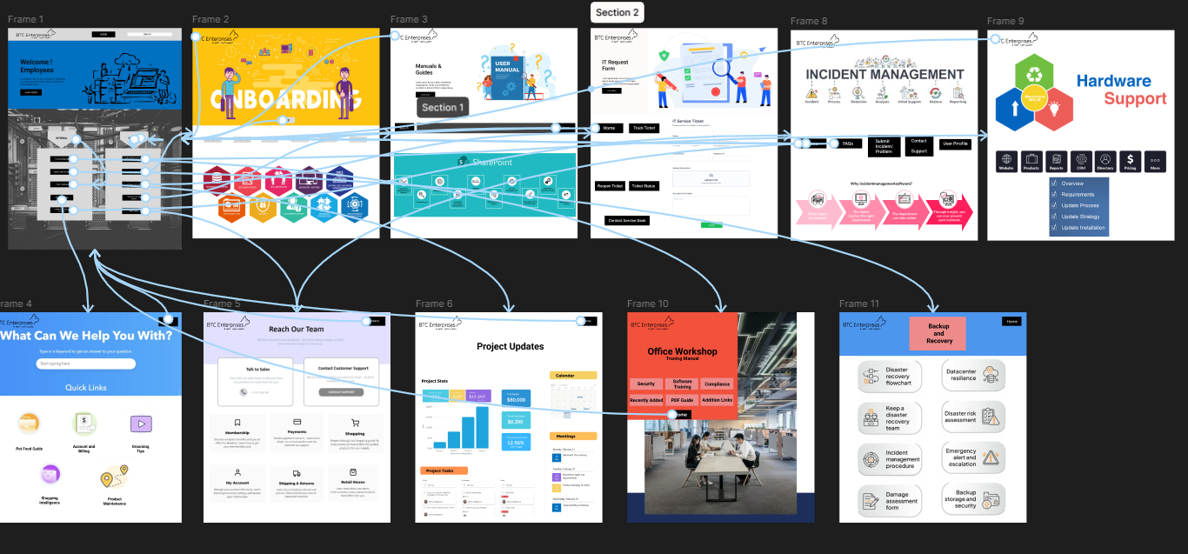

Figure 12: Prototype for the entire website

Figure 13: Prototype linking for all pages using the Homepage

Figure : Prototype linking of all pages

## Peer Review (Given)

|  |  |
| --- | --- |
| ***Title*** | Project Plan – Part #2 : Peer Review |
| ***Presenting Group*** | Group 4 |
| ***Reviewing Group*** | Group 5 |
| ***Timing*** | Did the group arrive on-time to present?  Comments: yes |
| ***Preparedness*** | Was the group ready (no delay in waiting for the prototype to load)?  Comments: Somewhat |
| ***Demo*** | Did the group explain the process they are going to demo?  Comments: yes  Were you able to understand the process being demonstrated?  Comments: yes  Did the prototype work as expected?  Comments: yes  Was there anything missing from the demo?  Comments: yes  What would you do to improve the demo?  Comments: the footer is too big and has a lot of information, since this is a SharePoint site for a department in the company not much information is needed in the footer |
| ***Visual Design*** | Does the visual design look aesthetically pleasing?  Comments: yes  What stood out that you liked?  Comments: yes  Was there anything that stood out that you did not like?  Comments: NO  What would you add to improve the design?  Comments: To change the footer format. |

## Peer Review (Received)

|  |  |
| --- | --- |
| ***Title*** | Project Plan – Part #2: Peer Review |
| ***Presenting Group*** | Group 5 |
| ***Reviewing Group*** | Group 7 |
|  |  |
| ***Timing*** | Did the group arrive on time to present?  Comments: Yes |
| ***Preparedness*** | Was the group ready (no delay in waiting for the prototype to load)?  Comments: yes |
| ***Demo*** | Did the group explain the process they are going to demo?  Comments: yes  Were you able to understand the process being demonstrated?  Comments: yes  Did the prototype work as expected?  Comments: yes  Was there anything missing from the demo?  Comments: yes  What would you do to improve the demo?  Comments: Might have completed the presentation onetime. |
| ***Visual Design*** | Does the visual design look aesthetically pleasing?  Comments: yes  What stood out that you liked?  Comments: The complete designs which connects to all pages and the links between pages  Was there anything that stood out that you did not like?  Comments: no  What would you add to improve the design?  Comments: Adding some more designs or sections to the main home page. |

## Client Review

|  |  |
| --- | --- |
| ***Title*** | Project Plan – Part #2: Client Review |
| ***Presenting Group*** | Group 5 |
|  |  |
| ***Timing*** | Did the group arrive on time to present?  Comments: Yes |
| ***Preparedness*** | Was the group ready (no delay in waiting for the prototype to load)?  Comments: Mostly |
| ***Demo*** | Did the group explain the process they are going to demo?  Comments: Yes  Were you able to understand the process being demonstrated?  Comments: Yes  Did the prototype work as expected?  Comments: Somewhat  Was there anything missing from the demo?  Comments: Prototype could have been working  What would you do to improve the demo?  Comments: Prototype could be tested earlier |
| ***Visual Design*** | Does the visual design look aesthetically pleasing?  Comments: Yes, It was a beautiful design.  What stood out that you liked?  Comments: Internal vs External users, design  Was there anything that stood out that you did not like?  Comments: N/A.    What would you add to improve the design?  Comments: The accessibility aspect can be researched for the design. |
| ***Group Members*** | Who was responsible for what when building this design?  The entire team. |

## Gantt Chart Tasks

Figure : Gantt Chart Tasks